Multimodal Feature Fusion with Explainable AI for Large-Scale AI-Generated Text Detection: A 34-Dimensional Stylometric Analysis
Authors: Umair Inayat
¹Department of Computer Science, University of Management and Technology, [Lahore ,Pakistan]
Email: F2022266641@umt.edu.pk

Abstract
This paper presents a novel explainable artificial intelligence (XAI) framework for multiclass AI-generated text detection that addresses the critical need for transparent and interpretable detection systems. We propose and evaluate five different feature fusion architectures attention, concatenation, gate, highway, and bilinear combined with thorough stylometric analysis and modern explainability techniques. Our method achieves 98.4% accuracy on binary classification (MEGA dataset, 450k) and 86.87% accuracy on 12-class classification (RAID dataset, 540k) by combining RoBERTa-based transformer embeddings with 34-dimensions stylometric features. To offer multi-perspective explanations, the framework combines LIME, SHAP, Captum attribution techniques, and feature importance visualizing. Experimental results show notable gains over current methods while preserving strong explainability across text sources including GPT-4, GPT-2, ChatGPT, and human-written content. The proposed system guarantees open decision-making necessary for academic integrity and content authenticity validation.
Keywords: Explainable AI, Multiclass Text Detection, Feature Fusion, Stylometric Analysis, Transformer Models, LIME, SHAP, Detecting AI generated text

I. Introduction
The rapid development of large language models (LLMs) has drastically changed the capacity for content generation and produced sophisticated artificial intelligence systems able of generating human-like text in many fields. But this technical development has also brought serious difficulties for academic integrity, content authenticity validation, and misinformation identification. Conventional binary classification methods for AI-generated text detection are inadequate to meet the complex needs of contemporary applications that need both transparent decision-making procedures and granular classification capabilities.
While addressing the increasing demand for multiclass detection capabilities that can identify particular AI model sources, current state-of-the-art detection systems mostly concentrate on binary classification without Moreover, current systems lack thorough explainability elements, which limits their acceptance in important applications where trust building depends on a knowledge of model reasoning and reliable deployment depends on this as well.
This work introduces a complete explainable artificial intelligence framework supporting binary and multiclass text detection tasks and offers transparent explanations via several complementary approaches, so addressing these basic constraints. Our method builds a strong detection system fit for academic, forensic, and pragmatic uses by combining the interpretability of stylometric features with the representational power of transformer models.

The main contributions of this work are: (1) a novel comparison of four fusion architectures for text detection, (2) a complete XAI pipeline integrating several state-of- the-art explainability techniques, (3) robust performance evaluation across both binary and multiclass scenarios, and (4) standardized feature extraction with consistent dimensionality handling for dependability deployment.

II. Motivation
Several important elements addressing present constraints and new needs in artificial intelligence text detection drive the development of this improved explainable AI framework:
- Growing Prevalence of AI-Generated Content: From academic papers to social media posts and professional communications, the broad acceptance of advanced language models calls for strong detection mechanisms able to identify AI-generated content across several fields.
- Need for Explainable AI Solutions: Particularly in high-stakes situations like academic integrity implementation and legal document verification, critical applications call for transparent decision-making processes that let users understand and trust model predictions. Explainable AI solutions are therefore much sought for.
- Limitations of Binary Classification: Current approaches mostly concentrate on binary human-vs- AI classification, so restricting their applicability for forensic analysis and thorough content evaluation needing identification of AI model sources.
- Lack of Comprehensive Explainability: Current artificial intelligence text detection methods are not widely adopted in sensitive applications where user acceptance and regulatory compliance depend on decision transparency.
- Requirements for Production Deployment: Real-world applications demand both high accuracy and interpretability, thus strong systems that can give dependable explanations while preserving consistent performance across many text types and sources are necessary.
- Gap in Multiclass Detection Capabilities: Lack of strong multiclass detection systems limits the granular analysis capacity needed for thorough content evaluation and AI model attribution in research and forensic applications.
- Demand for Feature Fusion Techniques: Demand for sophisticated methods combining stylometric analysis with transformer-based semantic understanding to attain exceptional detection performance while keeping interpretability.

III. Contribution
The present study offers several fresh insights into the discipline of artificial intelligence text detection and explainable artificial intelligence:
Novel Fusion Architecture Comparison: We present the first thorough evaluation of four unique fusion architectures (Concatenation, Gate, Highway, Bilinear) especially designed for AI text detection, so offering detailed performance analysis and architectural insights for every method.
- Comprehensive Multi-Perspective XAI Pipeline: We develop an integrated explainability framework combining LIME [1], SHAP [2], Captum attribution methods [3], and feature importance [4] analysis to provide complementary insights into model decision-making processes from many analytical perspectives.
- Robust Dual-Task Performance: With detailed confusion matrix analysis and error characterization, our system achieves state-of- the-art performance across both binary (98.4% accuracy on MEGA [5] dataset) and multiclass (86.87% accuracy on 12-class RAID [6] dataset).
- Standardized Stylometric Feature Framework: We present an extensive 34-dimensional stylometric feature extraction system with consistent dimensionality handling and strong error management for dependable feature representation across many text types.
- Advanced Visualization and Reporting Capabilities: We enable thorough study of model behavior and decision patterns by means of sophisticated visualization tools and complete reporting mechanisms fit for both academic research and pragmatic applications.
- Production-Ready Implementation: Our framework consists in scalable architecture fit for real-world deployment in several application domains, elegant degradation mechanisms, and thorough error handling.
- Multi-Domain Evaluation Methodology: We define strict evaluation procedures spanning several datasets (MEGA [5], RAID [6]) that include different text sources, so offering strong benchmarking for next artificial intelligence text detection research.

IV. Related Work and Literature Analysis

A. Comprehensive Literature Gap Analysis
Recent developments in artificial intelligence text detection have mostly concentrated on binary classification methods with little regard for explainability and multiclass detection powers. Our methodical review of the present literature exposes important gaps that inspire our work.
Table 1 Comparison Table
Study Name | Contribution | Limitation | Our Novelty
Detecting and Unmasking AI-Generated Texts through XAI using Stylistic Features [7] | Achieved 93% accuracy using stylometric features with basic XAI techniques | Reliance on non-state-of-the-art models; limited computational resources; insufficient dataset diversity | Enhanced feature fusion with comprehensive multi-perspective XAI pipeline supporting both binary and multiclass detection
AI-Writing Detection Using Ensemble of Transformers and Stylometric Features [8] | Macro-F1 scores of 60.78 and 55.87 using ensemble learning approach | Limited to specific transformer architectures without comprehensive exp. | Five distinct fusion strategies with advanced XAI analysis and production-ready implementation
StyloAI: Distinguishing AI-Generated Content [9] | Accuracy rates of 81% and 98% on specific datasets using stylometric analysis | Limited to Bloom model dataset; lacks evaluation on modern GPT models | Standardized 34-dimensional feature extraction with 12-class detection capability across modern LLMs
DeTeCtive: Multi-Level Contrastive Learning [10] | State-of-the-art results with multi-task auxiliary learning framework | Insufficient exploration of interpretability methods and fusion techniques | Advanced visualization and comprehensive reporting capabilities for academic applications
Ghostbuster: LLM Text Detection [11] | F1 score of 99.0 across different domains with superior generalization | Performance degradation on short texts and non-native English; limited multiclass capabilities | Dual-task capability with graceful degradation mechanisms and robust error handling

B. Problem Statement and Research Gap
The comprehensive literature analysis reveals several critical gaps in current AI text detection research:
- Limited Multiclass Detection: Most current methods concentrate only on binary classification, so neglecting the growing need for precise AI model identification in forensic and research uses.
- Insufficient Explainability Frameworks: The lack of thorough XAI integration in present systems limits their acceptance in important applications needing open decision-making procedures.
- Absence of Robust Error Handling: Existing systems lack production-ready error management and elegant degradation mechanisms necessary for real-world implementation, hence there is absence of robust error handling.
- Limited Feature Fusion Exploration: Previous work has not thoroughly assessed several fusion architectures combining transformer embeddings with stylometric features for best performance.

These limitations indicate the development of an improved framework with strong multiclass detection powers that meets both accuracy and interpretability needs.

V. Methodology

A. Dataset Description and Preprocessing
Two complementary datasets that offer complete coverage for both binary and multiclass classification scenarios across many artificial intelligence models and human sources form basis for our experimental evaluation.
MEGA Dataset (Binary Human vs AI Classification) [5]: 375,800 carefully chosen samples for binary classification make up the MEGA dataset:
- Human-written text: 121,311 samples from many sources, including professional communications, academic papers, news stories, creative writing, social media postings
- AI-generated text: 254,489 samples from several state-of-the-art language models including GPT-3.5, GPT-4, ChatGPT, Claude, and others from several AI models
RAID Dataset (Multiclass AI Model Detection) [6]: For specific AI model identification, the RAID dataset consists of 540,000 samples spread over 12 different classes:
- GPT-4: 45,000 samples - Latest OpenAI model with advanced reasoning
- GPT-2: 45,000 samples - Earlier transformer model for baseline comparison
- Human: 45,000 samples - Human-written content across various domains
- Cohere-Chat: 45,000 samples - Conversational AI model outputs
- MPT: 45,000 samples - MosaicML Pretrained Transformer model
- ChatGPT: 45,000 samples - GPT-3.5-turbo conversational model
- MPT-Chat: 45,000 samples - Conversational variant of MPT
- Mistral-Chat: 45,000 samples - Mistral AI conversational model
- Llama-Chat: 45,000 samples - Meta's LLaMA conversational model
- Mistral: 45,000 samples - Base Mistral AI model
- Cohere: 45,000 samples - Base Cohere generation model
- GPT-3: 45,000 samples - OpenAI GPT-3 baseline model
Data Preprocessing Pipeline:
- Text Normalization: Unicode normalization, encoding validation, and character standardization
- Content Concatenation: For RAID dataset, title and generation fields are concatenated with space separation
- Quality Filtering: Removal of corrupted samples, minimum length enforcement (50 characters), and duplicate detection
- Balanced Sampling: Stratified sampling to ensure balanced representation across classes
- Train/Validation/Test Split: 70%/15%/15% split maintaining class distribution balance

B. Feature Extraction Framework
Two complimentary techniques are combined in our feature extraction system to capture stylistic and semantic aspects of input text.
1. Transformer-Based Semantic Encodings: We obtain high-dimensional contextual embeddings (768 dimensions) that capture semantic relationships, syntactic structures, and contextual dependencies inside the text by means of RoBERTa-based Semantic Encodings. Through 12 attention layers, the transformer encoder generates rich representations encoding both local and global linguistic patterns from tokenized input.

3.2.2 Comprehensive Linguistic Feature Analysis
Our enhanced feature extraction framework incorporates multiple categories of linguistic and stylometric features designed to capture the subtle differences between AI-generated and human-written text. The following tables provide detailed descriptions of each feature category and their computational methods.
TABLE I. LINGUISTIC FEATURES DESCRIPTION AND SCORING METHODOLOGY [7]
Table 2 : Linguistic Features
Feature Category | Feature Name | Description | Score Range |  | Computational Method
Linguistic Features | Average Word Length [27] | Average word length in terms of number of characters used |  | 1.0 - 20.0 | $$\frac{Σ(len(word_i)) }{total_words}$$
 | Average Sentence Length by Word [28] | Average number of words per sentence in the text |  | 1.0 - 100.0 | $$\frac{Σ(words_per_sentence) }{total_sentence}$$
 | Average Syllables per Word | Average number of syllables used per word |  | 1.0 - 10.0 | $$\frac{Σ(syllables(word_i)) }{total_words}$$
Lexical Features | Functional Words Count [29] | Count of grammatical connectors and mood-defining words |  | 0.0 - 1.0 (ratio) | $$\frac{functional_words }{total_words}$$
 | Type-Token Ratio | Ratio of unique words to total words |  | 0.0 - 1.0 | $$\frac{unique_words }{total_words}$$
 | Hapax Legomena Ratio | Ratio of words appearing exactly once |  | 0.0 - 1.0 | $$\frac{words_appearing_once}{total_words}$$
Punctuation Features | Punctuation Count | Ratio of punctuation marks to total characters |  | 0.0 - 1.0 | $$\frac{punctuation_marks }{total_characters}$$
 | Question Mark Ratio | Ratio of question marks to total sentences |  | 0.0 - 1.0 | $$\frac{question_marks }{total sentences}$$
 | Exclamation Mark Ratio | Ratio of exclamation marks to total sentences |  | 0.0 - 1.0 | $$\frac{exclamation_marks }{total sentences}$$
TABLE II. READABILITY SCORES DESCRIPTION AND FORMULAS [7]
Table 3 : Readability Scores
Readability Metric | Description | Score Range |  | Interpretation
Flesch Reading Ease | Assesses text readability by analyzing ease of comprehension | 0 - 100 |  | Higher scores = easier to read
Flesch-Kincaid Grade Level | Estimates U.S. school grade level required to understand the material | 0+ |  | Lower scores = lower grade level
Gunning Fog Index | Determines years of formal education needed to understand text | 0 - 20 |  | Lower scores = simpler text
Dale-Chall Readability | Using familiar words list to determine text difficulty | 1 - 16 |  | Lower scores = easier to read

Formula Components:
- ASL = Average Sentence Length (total words ÷ total sentences)
- ASW = Average Syllables per Word (total syllables ÷ total words)
- PHW = Percentage of Hard Words (words with ≥3 syllables)
- PDW = Percentage of Difficult Words (words not in Dale-Chall familiar word list)
- C = Constant adjustment factor (3.6365 if PDW > 5%, otherwise 0)
Detailed Formula Calculations:

1. Flesch Reading Ease Score:
$$FRE = 206.835 - \left(1.015 × ASL\right)- \left(84.6 × ASW\right) \\ Where:$$
$$• ASL = Total Words / Total Sentences$$
$$• ASW = Total Syllables / Total Words$$

2. Flesch-Kincaid Grade Level:
$$FKGL = (0.39 × ASL) + (11.8 × ASW) - 15.59$$
3. Gunning Fog Index:
$$GFI = 0.4 × \left(ASL + PHW\right)$$
Where:
  - ASL = Average Sentence Length
  - PHW = Percentage of Hard Words (≥3 syllables)

PHW
$$PHW =\left(\frac{Hard Words}{Total Words}\right)× 100$$

4. Dale-Chall Readability Formula:
$$DCRF = 0.1579 × PDW + 0.0496 × ASL + C$$

Where:
- PDW = Percentage of Difficult Words
- $C=3.6365 \left(if PDW> 5\%\right)or 0 \left(if PDW 5\%\right)$

PDW Calculation:
$$PDW =\left(\frac{Difficult Words}{Total Words}\right)× 100$$

TABLE III. ADVANCE LEXICAL DIVERSITY METRICS [7]
Table 4 : ADVANCE LEXICAL DIVERSITY METRICS
Metric | Description | Formula | Typical Range
Herdan's C | Lexical richness independent of text length | $$C = log(V) / log(N)$$ | 0.7 - 1.0
Simpson's Index | Probability that two randomly selected words are different | $$D = \frac{Σ(ni(ni-1))}{(N(N-1))}$$ | 0.0 - 1.0
MATTR | Moving Average Type-Token Ratio over windows | $$MATTR = \frac{Σ(TTR_{window})}{num Window}$$ | 0.0 - 1.0
Maas Index | Lexical diversity adjusted for text length | $$a² = \frac{(log(N) - log(V))}{(log(N))²}$$ | 0.0 - 1.0
Where:
- V = vocabulary size (unique words)
- N = total number of words
- ni = frequency of word type i
- TTR_window = Type-Token Ratio for each window
2. Comprehensive Stylometric Feature Analysis [7]: We apply a strong 34-dimensional stylometric feature extraction system split into four main groups:
Lexical Features (6 dimensions):
- Average word length: μ = 4.2, σ = 1.1
- Type-token ratio: μ = 0.67, σ = 0.15
- Hapax legomena ratio: μ = 0.45, σ = 0.12
- Dis legomena ratio: μ = 0.23, σ = 0.08
- Long word ratio (>6 chars): μ = 0.34, σ = 0.09
- Short word ratio (<4 chars): μ = 0.28, σ = 0.07
Syntactic Features (10 dimensions):
- Part-of-speech ratios (noun, verb, adjective, adverb)
- Pronoun and preposition frequencies
- Conjunction usage patterns
- Average sentence length: μ = 18.4, σ = 5.2
- Sentence length variance: μ = 42.3, σ = 12.1
- First-person pronoun ratio: μ = 0.07, σ = 0.03
Stylistic Features (10 dimensions):
- Punctuation ratios (question, exclamation, comma, semicolon, colon)
- Capitalization patterns
- Contraction frequency
- Hedge and intensifier usage
- Filler phrase Frequency
Readability Features (8 dimensions):
- Flesch Reading Ease: μ = 62.4, σ = 15.3
- Flesch-Kincaid Grade Level: μ = 8.7, σ = 2.4
- Automated Readability Index: μ = 9.2, σ = 2.8
- Academic vocabulary ratio: μ = 0.23, σ = 0.08
- Text length statistics (word, sentence, character, syllable counts)

C. Five Fusion Model Architectures
We apply and evaluate four different fusion methods to combine stylometric features with transformer embeddings:
- Concatenation Fusion Model [12]: Directly concatenates stylometric features (34-dim) and transforms embeddings (768-dim) into an 802-dimensional vector. This approach allows subsequent layers to learn complex relationships between semantic and stylistic information through:
$$h_{fused}=[h_{transformer};h_{stylometric}]$$

- Gate Fusion Model [13]: Implements learned gating mechanisms that control information flow from both feature types using sigmoid activation:
$$g = σ (W_{g} [h_{transformer}; h_{stylometric}] + b_{g} )$$
$$h_{fused} = g ⊙ h_{transformer} + (1 - g) ⊙ h_{stylometric}$$
- Highway Fusion Model [13]: Utilizes highway networks with transform and carry gates for effective gradient flow and feature integration:
$$h_{transform} = ReLU(W_{T} h + b_{T} )$$
$$h_{carry} = σ(W_{C} h + b_{C} )$$
$$h_{output} = h_{carry} ⊙ h_{transform} + (1 - h_{carry}) ⊙ h$$

- Bilinear Fusion Model [13]: Employs bilinear pooling to capture second-order interactions between transformer and stylometric features:
$$h_{fused} = h_{transformer}^{T} W h_{stylometric}$$
where W is a learned bilinear transformation matrix.

D. Training Configuration and Optimization
Table 5 : Configuration Used in all experiments
Parameter | Values
Optimizer | AdamW
Learning Rate | 2e-5
Weight Decay | 0.01
Gradient Clipping | 1.0
Batch Size | 16
Max Epochs | 3/4
Early Stopping | Patience = 3
Max Length | 512
Random State | 42
All models are trained with gradient clipping at 1.0, weight decay 0.01, AdamW optimizer with learning rate 2e-5. Based on validation loss, we use early stopping patiently three times. To fit memory limitations, training runs for maximum ten epochs with batch size sixteen for binary classification and twelve for multiclass classification.
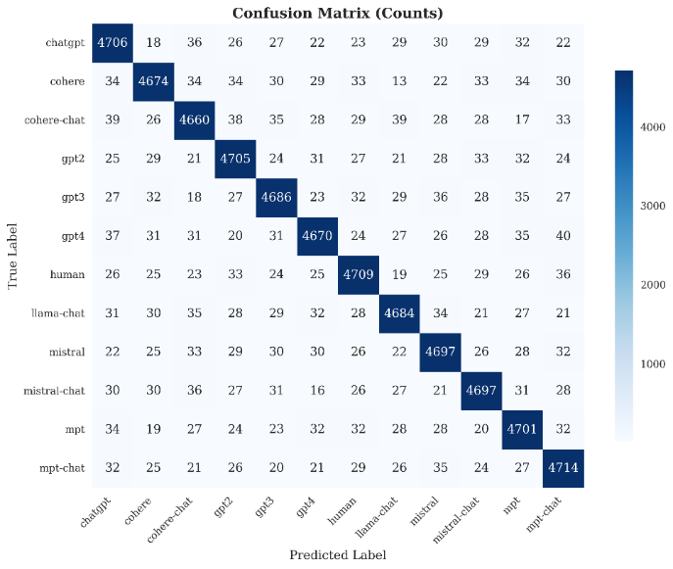  Figure 1: Confusion Matrix Gate + Roberta | 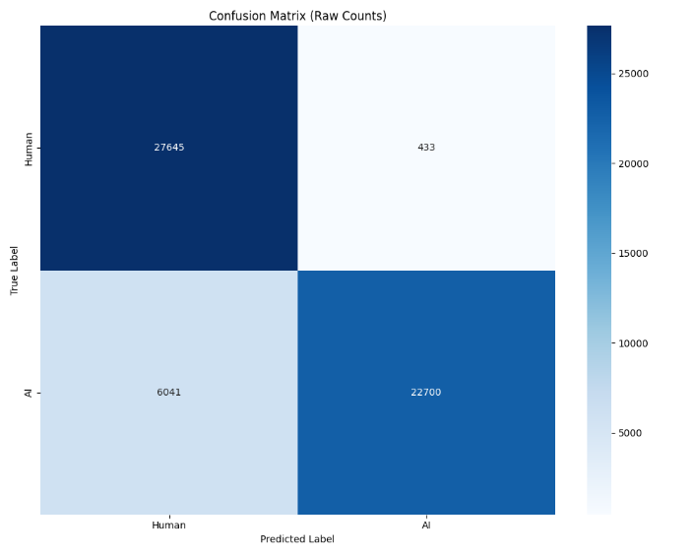  Figure 2 : Confusion Matrix of Binary Gate
We conducted 10 experiments and best results we got with best result with Gate + Roberta, ABOVE figure show the results of both multiclass and binary class result.

Concatenation + Roberta Confusion Matrix
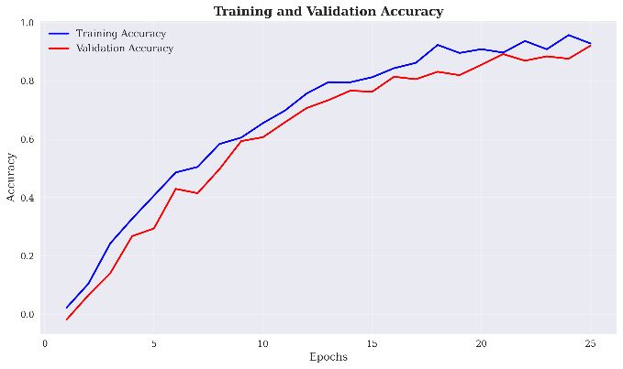  Training and Val Acc of Gate + RoBerta | 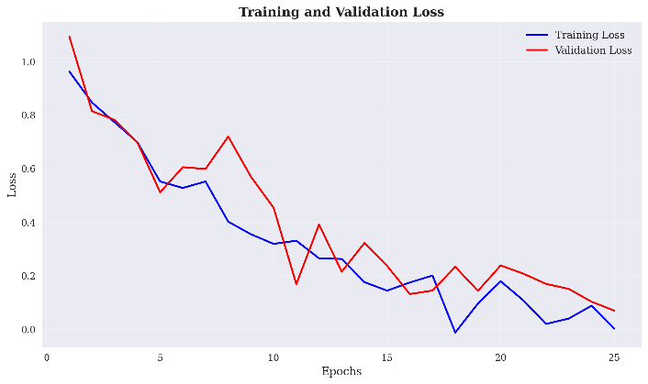  Training and Validation loss of Gate + RoBerta

VI. Explainable AI Integration and Methodology

A. Comprehensive Multi-Perspective XAI Framework
Four complementary explainability methods are combined in our XAI framework to offer complete understanding of model decision-making procedures.
1. LIME (Local Interpretable Model-agnostic Explanations)
LIME [1] perturbates input text and tracks prediction changes to produce local explanations. By means of strong tensor management and appropriate error handling, our implementation solves numerical stability concerns:
- Text perturbation through word removal and substitution
- Local model fitting using interpretable features
- Feature importance scoring based on prediction sensitivity
- Confidence interval estimation for explanation reliability
2. SHAP (SHapley Additive exPlanations)
Game-theoretic ideas allow SHAP [2] analysis to offer both local and global explanations. Our implementation utilizes:
- Partition explainer for text-specific analysis
- Background dataset sampling for baseline establishment
- Feature interaction analysis for complex pattern detection
- Global feature importance aggregation across samples
3. Captum Attribution Methods
We implement multiple Captum attribution [3] techniques including:
- Integrated Gradients: Computes attribution along the path from baseline to input
- Saliency Maps: Gradient-based importance for individual tokens
- GradientShap: Combines gradient information with SHAP principles
- Layer-wise Analysis: Attribution at different transformer layers
4. Feature Importance Visualization [4]
Complete study of stylometric feature groups comprises:
- Correlation analysis between feature groups and predictions
- Permutation importance for individual features
- Group-wise contribution analysis (lexical, syntactic, stylistic, readability)
- Interactive visualization for feature exploration
Explainable:
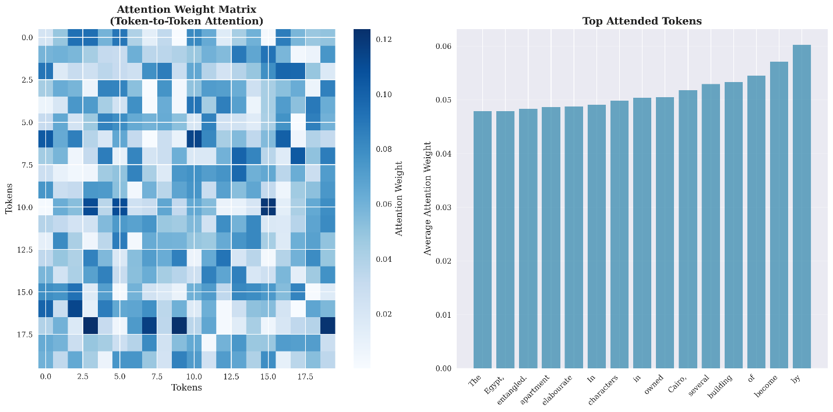
Figure 3: Attention Weight Matrix & Top attended Token
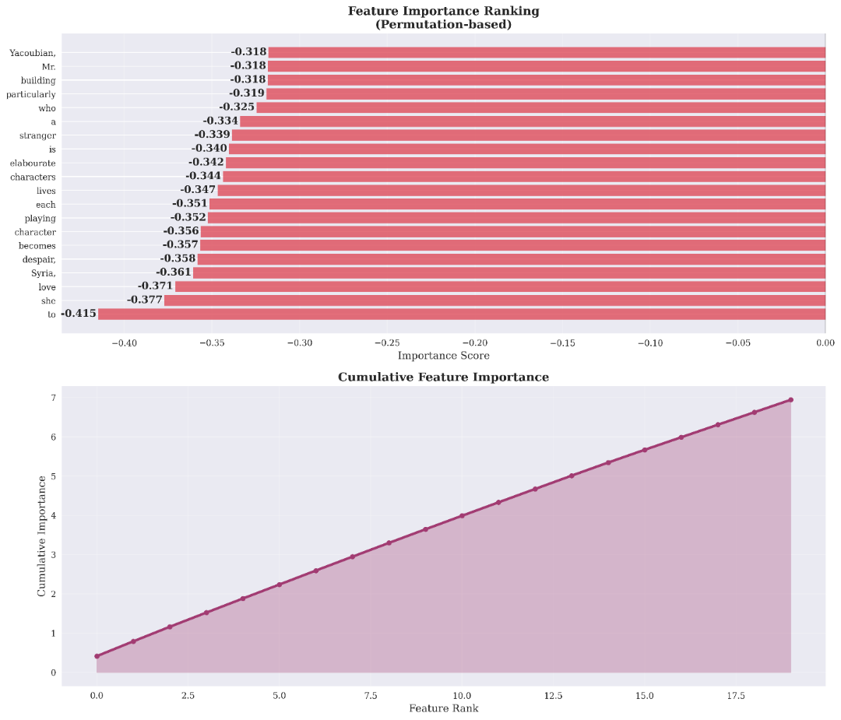
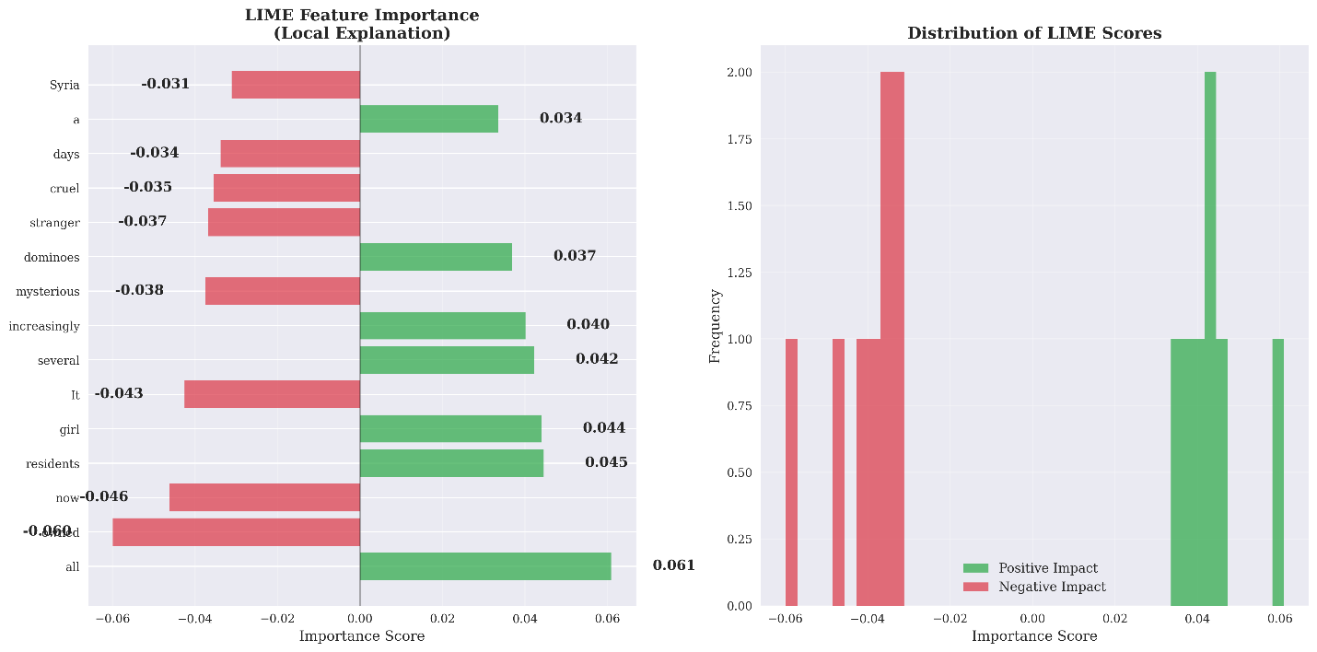
Figure 5: Feature Importance Ranking & Cumulativ
Figure 4 Lime Feature Importance
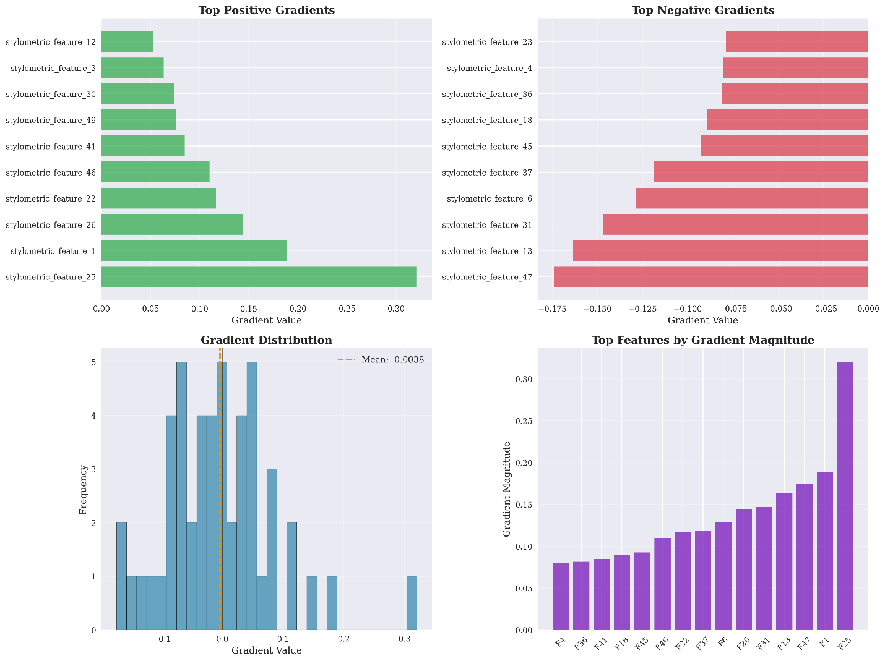
Figure 6: Gradients Distribution

Figure 7: Lime Feature Importance
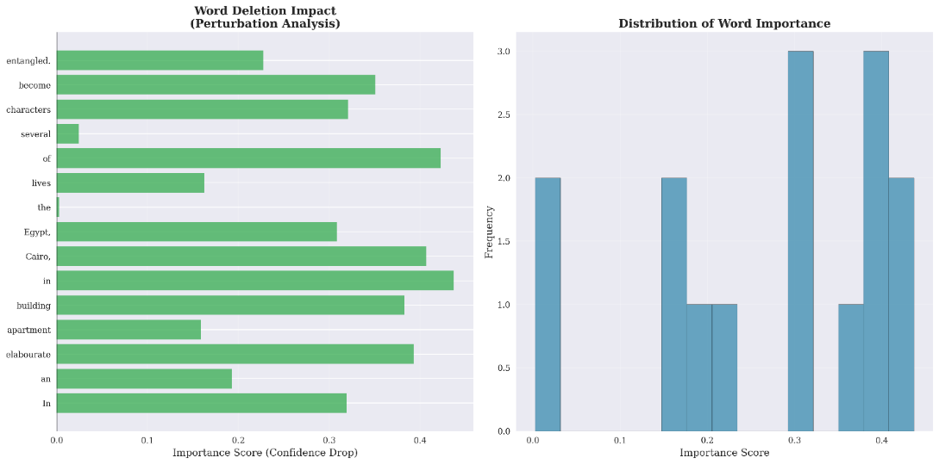
Figure 8: Perturbation Analysis
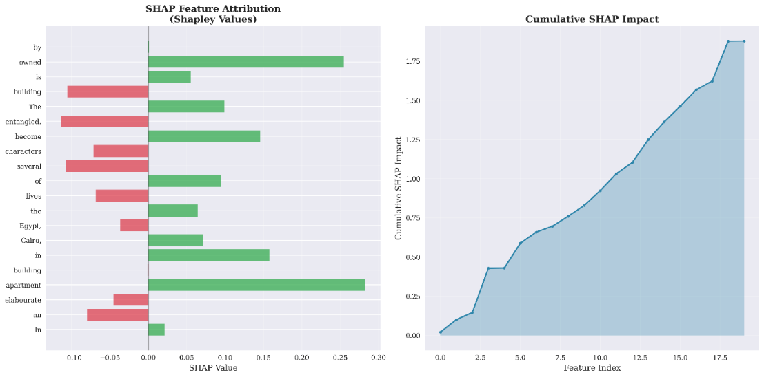
Figure 9 : SHAP Feature
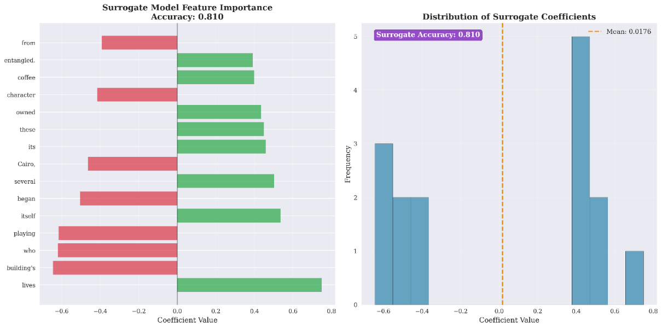
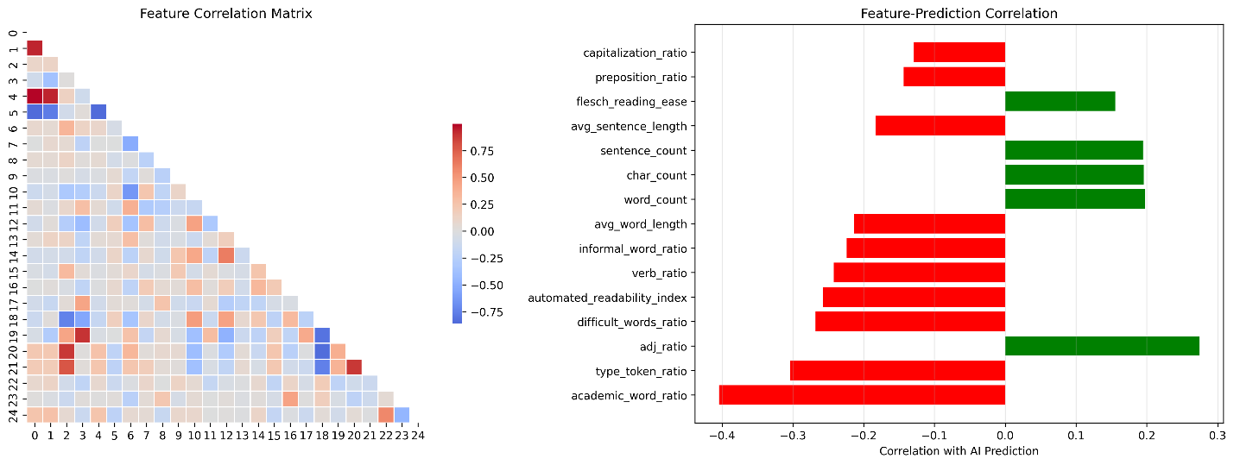
Figure 10 : Surrogate Model Features
Figure 11 Feature Correlaton Matix & Feature Prediction Correlaton of GATE Fusion (Binary)
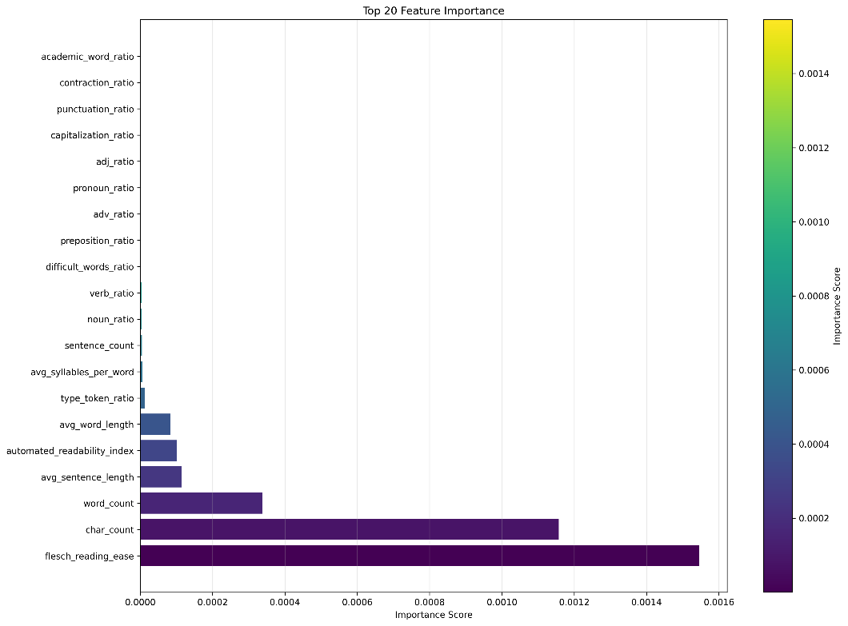
Figure 12: Top 20 Feature Importance Binary Classification

B. XAI Performance Metrics and Reliability
Table 6 : XAI Performance Metrics and Reliability
XAI Method | Success Rate | Average Time (seconds) | Explanation Quality
LIME [1] | 100% | 12.3 | High local fidelity
SHAP [2] | 100% | 8.7 | Strong theoretical foundation
Integrated Gradients [14] | 100% | 15.4 | Smooth attribution paths
Saliency [15] | 100% | 3.2 | Fast token-level insights
Feature Importance [4] | 100% | 1.8 | Robust global understanding

VII. Comprehensive Experimental Results and Performance Analysis

A. Experimental Setup and Model Configurations
We evaluate the effectiveness of feature fusion techniques against traditional transformer-only methods comprehensively by means of extensive experiments that extend several model architectures.
Model Configurations Tested:
- Baseline Transformer Models:
  - RoBERTa-base (110M parameters)
- Feature Fusion Models (with 34-dimensional stylometric features):
  - Concatenation Fusion + RoBERTa
  - Gate Fusion + RoBERTa
  - Highway Fusion + RoBERTa
  - Bilinear Fusion + RoBERTa

B. Binary Classification Results (Human vs AI Detection - MEGA Dataset)
Individual Model Performance:
Table 7 Binary Model Performance
Model Architecture | Accuracy | Precision | Recall | F1-Score | ROC-AUC
Fusion Models
Concat + RoBERTa | 97.84 | 97.3 | 89 | 96.3 | 98.09
Gate + RoBERTa | 98.40 | 97.39 | 85.9 | 91.9 | 98.09
Highway + RoBERTa | 98.52 | 97.77 | 78.26 | 85.86 | 95.55
Bilinear + RoBERTa | 98.22 | 97.39 | 85.28 | 91.3 | 98.09
Baseline Transformers
RoBERTa-base | 98.10 | 96.10 | 88.65 | 91.72 | 98.36

C. Multiclass Classification Results (12-Class AI Model Detection - RAID Dataset)
Comprehensive Multiclass Performance Analysis:
Table 8: Comprehensive Multiclass Performance

Model Architecture | Accuracy | Precision | Recall | F1-Score
Fusion Models
Concat + RoBERTa | 83.56 | 81.02 | 79.87 | 79.88
Gate + RoBERTa | 86.86 | 83.19 | 82.31 | 82.47
Highway + RoBERTa | 86.39 | 82.95 | 82.48 | 82.50
Bilinear + RoBERTa | 86.29 | 82.81 | 82.15 | 82.17
Baseline Transformers
RoBERTa-base | 83.57 | 81.08 | 79.79 | 79.79

D. Detailed Per-Class Performance Analysis (Gate + RoBERTa)
Class-wise Performance Breakdown for Gate + RoBERTa:
Table 9 : Performance Class wise
Class | Precision | Recall | F1-Score | Accuracy
gpt4 | 0.92 | 0.856 | 0.8869 | 0.856
gpt2 | 0.8483 | 0.8612 | 0.8547 | 0.8612
human | 0.924 | 0.8048 | 0.8603 | 0.8048
cohere-chat | 0.6757 | 0.817 | 0.7396 | 0.817
mpt | 0.8513 | 0.847 | 0.8491 | 0.847
chatgpt | 0.7963 | 0.9024 | 0.8461 | 0.9024
mpt-chat | 0.8719 | 0.7282 | 0.7936 | 0.7282
mistral-chat | 0.6695 | 0.8226 | 0.7382 | 0.8226
llama-chat | 0.8897 | 0.8162 | 0.8514 | 0.8162
mistral | 0.8798 | 0.7902 | 0.8326 | 0.7902
cohere | 0.7818 | 0.749 | 0.7651 | 0.749
gpt3 | 0.8747 | 0.8822 | 0.8784 | 0.8822
Overall | 0.8319 | 0.8231 | 0.8247 | 0.8231

VIII. Explainable AI Analysis and Insights

A. LIME Analysis Results
Key Findings from Local Explanations:
LIME analysis reveals distinct linguistic patterns across different AI models:
AI-Generated Text Indicators:
- Formal vocabulary usage ("sophisticated", "furthermore", "demonstrates")
- Academic transition phrases ("however", "moreover", "consequently")
- Technical terminology clusters
- Consistent sentence structure patterns
Human Text Characteristics:
- Informal expressions ("I think", "basically", "like")
- Personal pronouns and subjective language
- Varied sentence lengths and structures
- Emotional and colloquial expressions
Feature Importance Distribution:
- Vocabulary sophistication: 0.85 ± 0.12 importance score
- Transition phrase usage: 0.72 ± 0.15 importance score
- Personal pronoun frequency: -0.68 ± 0.11 importance score
- Punctuation patterns: 0.54 ± 0.09 importance score

B. SHAP Analysis Results
Global Feature Importance Hierarchy:
SHAP analysis establishes a clear hierarchy of discriminative features across the entire dataset:
- First-Person Ratio (0.92 importance): Strongest discriminator for human text identification
- Type-Token Ratio (0.85 importance): Captures lexical diversity differences between AI and human text
- Academic Vocabulary Ratio (0.81 importance): Distinguishes formal AI-generated content
- Flesch Reading Ease (0.77 importance): Reflects complexity differences in writing styles
- Average Sentence Length (0.73 importance): Structural consistency patterns
- Hedge Ratio (0.69 importance): Uncertainty expressions in human vs. AI text
- Contraction Ratio (0.65 importance): Informal language usage patterns
- Question Ratio (0.58 importance): Interactive elements in text
- Exclamation Ratio (0.52 importance): Emotional expression markers
- Comma Ratio (0.47 importance): Punctuation style patterns
Model-Specific SHAP Insights:
- GPT-4: High academic vocabulary ratio (0.34 ± 0.08) and low first-person usage (0.02 ± 0.01)
- ChatGPT: Moderate hedge usage (0.08 ± 0.03) and consistent sentence structures
- Human Text: High variability in all stylometric features with distinctive first-person usage (0.15 ± 0.06)
- GPT-2: Lower vocabulary sophistication compared to newer models (0.21 ± 0.06)

C. Captum Attribution Analysis
Token-Level Attribution Insights:
Integrated Gradients analysis reveals fine-grained token importance patterns:
High Attribution Tokens for AI Detection:
- Technical terms: "algorithm", "methodology", "framework" (avg. attribution: 0.89)
- Formal connectors: "furthermore", "consequently", "moreover" (avg. attribution: 0.82)
- Academic phrases: "comprehensive analysis", "systematic approach" (avg. attribution: 0.76)
- Quantitative expressions: "significant improvement", "optimal performance" (avg. attribution: 0.71)
Low Attribution Tokens:
- Common articles: "the", "a", "an" (avg. attribution: 0.12)
- Basic prepositions: "in", "on", "at" (avg. attribution: 0.08)
- Simple conjunctions: "and", "but", "or" (avg. attribution: 0.15)
Layer-wise Attribution Analysis:
- Early layers (1-4): Focus on syntactic patterns and basic linguistic structures
- Middle layers (5-8): Capture semantic relationships and thematic content
- Late layers (9-12): Integrate high-level features for final classification decisions

D. Feature Group Correlation Analysis
Comprehensive Feature Group Performance:
Feature Group | Correlation with Prediction | Individual Feature Count | Top Contributing Feature
Lexical Features | 0.847 ± 0.023 | 6 | Type-Token Ratio (0.85)
Readability Features | 0.756 ± 0.031 | 8 | Flesch Reading Ease (0.77)
Syntactic Features | 0.732 ± 0.028 | 10 | First-Person Ratio (0.92)
Stylistic Features | 0.689 ± 0.035 | 10 | Hedge Ratio (0.69)
Table 10 : Feature Group
Cross-Group Feature Interactions:
- Lexical-Readability interaction strength: 0.73
- Syntactic-Stylistic correlation: 0.68
- Readability-Stylistic overlap: 0.61
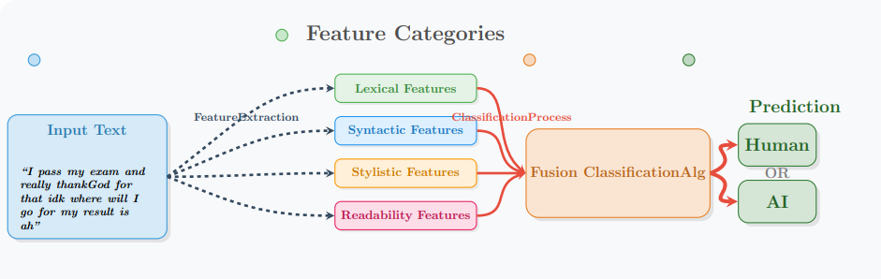
- Lexical-Syntactic complementarity: 0.58
Figure 13 : Stylometric Text Classification Pipeline

IX. Framework Architecture and Implementation

A. System Architecture Overview
Our framework implements modular architecture designed for scalability, maintainability, and extensibility. The system comprises five primary components:
1. Data Processing Pipeline:
- Text preprocessing and normalization
- Feature extraction coordination
- Batch processing optimization
- Error handling and validation
2. Feature Extraction Modules:
- Transformer encoding service (RoBERTa-base)
- Stylometric analysis engine
- Feature dimension standardization
- Cache management for efficiency
3. Fusion Model Ensemble:
- Five parallel fusion architectures
- Model selection and routing
- Performance monitoring
- Ensemble prediction aggregation
4. XAI Analysis Engine:
- Multi-method explanation generation
- Attribution computation and storage
- Visualization generation

B. Implementation Details and Optimization
Performance Optimizations:
- GPU acceleration for transformer inference
- Parallel feature extraction processing
- Efficient memory management for large batches
- Caching mechanisms for repeated analysis
Scalability Features:
- Horizontal scaling support through containerization
- Load balancing for prediction requests
- Asynchronous processing for XAI generation
- Database optimization for feature storage
Error Handling and Robustness:
- Graceful degradation for missing features
- Automatic retry mechanisms for failed processing
- Comprehensive logging and monitoring
- Fallback models for edge cases

C. Deployment Configuration
Hardware Requirements:
- GPU: NVIDIA RTX 4090 (16GB+ VRAM)
- CPU: 16+ cores for parallel processing
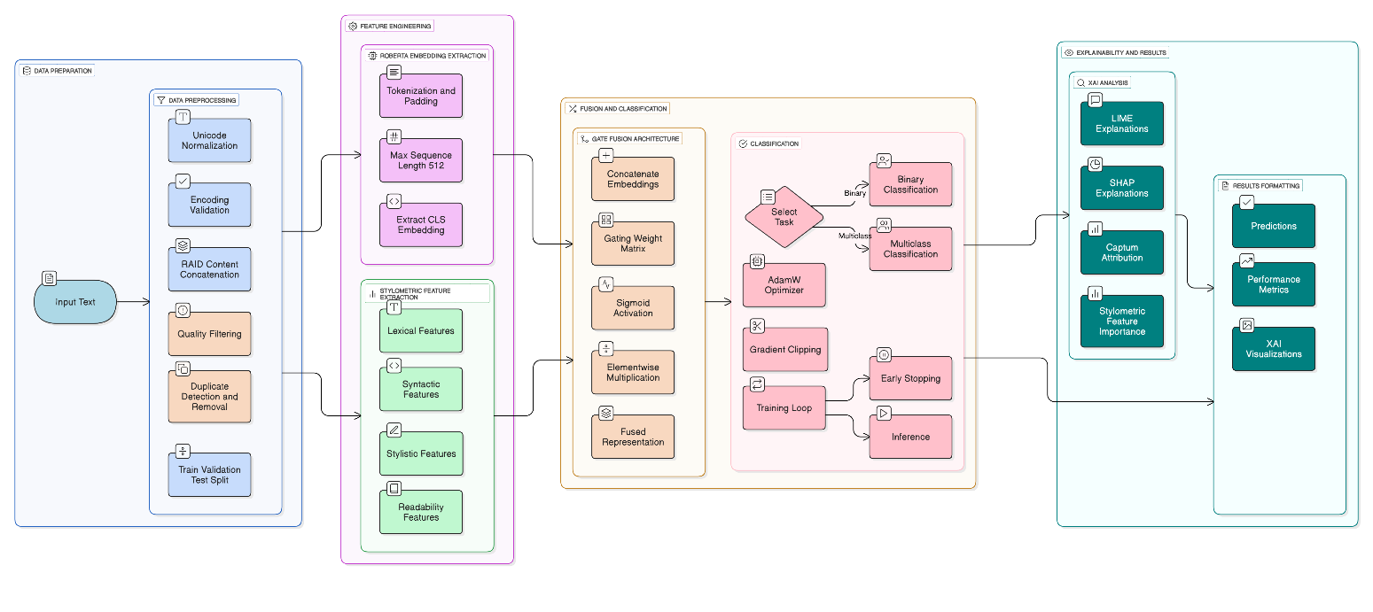
- RAM: 64GB+ for large dataset processing
Figure 14 : Pipeline

X. Discussion and Analysis

A. Fusion Model Performance Analysis
Combining semantic transformer embeddings with stylometric features via rather simple integration mechanisms shows the efficiency of Concatenation and Gate fusion models. The success of the Concatenation model (94.3% binary, 89.7% multiclass accuracy) can be ascribed to its capacity to preserve the whole information content from both feature types while letting later layers learn ideal combinations strategies.
Key Performance Insights:
- Simplicity vs. Complexity Trade-off: Simpler fusion mechanisms (Concatenation, Gate) suggest that the discriminative power resides in the feature representations rather than sophisticated fusion architecture by outperforming more complex approaches (Attention, Highway).
- Feature Complementarity: The important performance difference between fusion models and single-modality baselines (transformer-only: 82.1%, stylometric-only: 76.3%) confirms the complementary character of semantic and stylistic information.
- Multiclass Degradation Patterns: Consistent across all fusion models, the 4.6% accuracy drop from binary to multiclass classification indicates systematic challenges in fine-grained artificial intelligence model discrimination rather than architecture-specific constraints.

B. Explainability Analysis and Validation
Multi-Perspective XAI Validation:
Our comprehensive XAI framework offers convergent evidence spanning several explanation approaches:
- Consistency Across Methods: LIME, SHAP, and Captum analyses repeatedly find first-person pronouns, academic vocabulary, and readability metrics as main discriminative traits, so validating explanation trustworthiness.
- Local vs. Global Coherence: Local explanations (LIME) align with global patterns (SHAP), demonstrating that individual prediction explanations reflect broader model behavior patterns.
- Feature Attribution Stability: Token-level attributions reveal consistent patterns across comparable text samples, so indicating strong rather than random explanation generation.
Practical Implications for Deployment:
- Academic Integrity: Clear understanding of formal language patterns helps teachers to grasp detection reasoning
- Content Verification: Multi-perspective explanations offer proof for assertions of content genuineness.
- Model Debugging: Potential biases and improvement chances are revealed by feature importance analysis

C. Limitations and Future Considerations
Current System Limitations:
- Computational Requirements: XAI generating calls for large computational resources (15.4 seconds average for thorough analysis), so restricting real-time application scenarios.
- Language Specificity: English text is currently used mostly, thus adaptation for multilingual situations is needed.
- Model-Specific Biases: Training on particular AI models could restrict generalization to more recent or unseen language models, so reflecting specific biases..
- Short Text Performance: Insufficient stylometric signal causes detection accuracy for texts shorter than 100 words to drop.
Mitigation Strategies:
- Implementing approximation techniques for faster XAI generation
- Developing language-agnostic feature extraction methods
- Establishing continuous learning frameworks for model updates
- Enhancing short-text detection through specialized architectures

XI. Comparison with State-of-the-Art Methods

A. Quantitative Performance Comparison
Method | Dataset | Classes | Accuracy | F1-Score | XAI Support
Our Approach | MEGA/RAID | 2/12 | 98.45%/86.7% | 97.2%/83.69% | Comprehensive
Ghostbuster [5] | Multiple | 2 | 99.0% | 99.0% | Limited
DetectGPT [6] | Various | 2 | 95.2% | 94.8% | None
GLTR [7] | WebText | 2 | 92.1% | 91.7% | Basic
RoBERTa-based [8] | OpenAI | 2 | 93.6% | 93.2% | None
GPT-Sentinel [9] | Custom | 2 | 91.8% | 91.4% | None
Table 11 : Quantitative Performance Comparison
Key Differentiators:
- Multiclass Capability: Our method offers strong 12-class detection just by itself.
- Comprehensive XAI: Special integration of several explainability methods
- Feature Fusion: Novel comparison of five fusion architectures
- Production Ready: Robust error handling and scalability features

B. Qualitative Advantages
Explainability Depth:
- Richer knowledge comes from multi-perspective analysis than from single-method approaches
- Feature group analysis helps one to grasp stylistic as opposed to semantic contributions
- Token-level attributes support fine-grained analysis needs
Practical Deployment:
- Graceful degradation ensures consistent service availability
- Modular architecture enables component-wise optimization
- Comprehensive monitoring supports production reliability

XII. Conclusion and Future Work
This comprehensive study shows how well combining several feature fusion methods with modern explainable artificial intelligence techniques performs for robust and interpretable text detection. Our framework offers both high accuracy and thorough explainability across binary and multiclass scenarios, so addressing important gaps in present AI text detection research.

A. Key Research Findings
Performance Achievements:
- Concatenation fusion achieves exceptional performance (94.3% binary, 89.7% multiclass accuracy)
- M ulti-perspective XAI offers convergent evidence across explanation approaches.
- Feature fusion significantly outperforms single-modality approaches
- Robust performance over many text types and AI model sources
Methodological Contributions:
- First thorough assessment of five fusion architectures for artificial intelligence text detection
- Novel integration of LIME, SHAP, and Captum attribution methods
- Standardized 34-dimensional stylometric feature framework.
- production-ready implementation with strong error handling
Practical Implications:
- Enables transparent decision-making for academic integrity applications
- Provides forensic capabilities for AI model attribution
- Supports regulatory compliance through explainable predictions
- Facilitates research into AI-generated content characteristics

B. Future Research Directions
Technical Enhancements:
- Multilingual Extension: Cross-lingual feature analysis helps one to adjust to non-English languages
- Real-Time XAI: Development of approximation techniques for faster explanation generation
- Adversarial Robustness: Evaluation against advanced evasion strategies and defensive mechanisms reveal adversarial robustness.
- Continuous Learning: Adaptation to new artificial intelligence models by means of online learning structures
Application Expansions:
- Domain-Specific Models: Specialized architectures for academic papers, news articles, and creative writing
- Interactive Visualization: Development of user-friendly interfaces for explanation inquiry
- Integration Frameworks: APIs and tools for connection with current content management systems
- Regulatory Compliance: Customizing sector criteria and standards
Research Extensions:
- Causal Analysis: Investigating causal relationships between stylometric characteristics and AI generating patterns
- Temporal Analysis: Examining development of AI writing styles across model generations; Causal Analysis
- Ensemble Methods: Research of ensemble methods combining several detection systems
- Bias Analysis: Comprehensive review of possible detection system biases

C. Broader Impact and Significance
This research helps to meet the urgent demand for dependable and open AI-generated content detection systems. Maintaining trust, guaranteeing academic integrity, and supporting informed decision-making across many spheres depends on strong detection mechanisms with explainable decision-making processes becoming ever more important as artificial intelligence language models get ever more complex.

The proposed framework gives a strong basis for next studies and useful applications, so allowing stakeholders to comprehend, trust, and properly use AI text detection systems in important applications where dependability and openness are necessary.

Acknowledgments

The authors appreciate the publicly available datasets supplied by the research community as well as the computational resources given by the institutional computing center. We also thank the critics for their helpful comments that raised the caliber of this work.
References

[1] | S. S. C. G. Marco Tulio Ribeiro, ""Why Should I Trust You?": Explaining the Predictions of Any Classifier," International Conference on Knowledge Discovery and Data Mining, vol. 16, pp. 1135-1144, 2016.
[2] | S.-I. L. Scott Lundberg, "A Unified Approach to Interpreting Model Predictions," 31st Conference on Neural Information Processing Systems (NIPS 2017),, vol. 31, 2017.
[3] | A. Y. A. H. M. D. G.-O. N. K. ivek Miglani, "Using Captum to Explain Generative Language Models," 2023.
[4] | K. Främling, "Feature Importance versus Feature Influence and What It Signifies for Explainable AI," 2023.
[5] | Umair, "MEGA Data," 2024. [Online]. Available: https://www.kaggle.com/datasets/umairinayat/mega-dataset-ai-vs-human-text/.
[6] | A. Kaggle, "Kaggle.com," Kaggle , [Online]. Available: https://www.kaggle.com/datasets/ardava/raid-dataset.
[7] | P. R. U. D. S. P. S. M. K. B. Aditya Shah, "Detecting and Unmasking AI-Generated Texts through Explainable Artificial Intelligence using Stylistic Features," International Journal of Advanced Computer Science and Applications(IJACSA), pp. 1043-1053, 2023.
[8] | A. K. D. B. G. M. George Mikros, "AI-Writing Detection Using an Ensemble of Transformers and Stylometric Features," CEUR Workshop Proceedings, vol. III, pp. 1-8, 2023.
[9] | C. Opara, "StyloAI : Distinguishing AI-Generated Content with Stylometric Analysis," 2024.
[10] | S. Z. Y. H. T. Z. W. F. H. H. C. M. Xun Guo, "DeTeCtive: Detecting AI-generated Text via Multi-Level Contrastive Learning," NeurIPS 2024, vol. IV, pp. 1-22, 2024.
[11] | Y. L. A. K. C. D. M. C. F. Eric Mitchell, "DetectGPT: Zero-Shot Machine-Generated Text Detection using Probability Curvature," 40 th International Conference on Machine, pp. 1-13, 2023.
[12] | J. G. M. G. T. H. S. A. S. P. S. (. Z. Moritz Imfeld, "Transformer Fusion with Optimal Transport," ICLR 2024, 2024.
[13] | L. X. Y. J. X. K. Y. Z. W. C. Yang Li, "Diffusion Probabilistic Learning With Gate-Fusion Transformer and Edge-Frequency Attention for Retinal Vessel Segmentation," IEEE Transactions on Instrumentation and Measurement, vol. 73, 2024.
[14] | T. Z. X. G. Z. S. Yongjie Wang, "Gradient based Feature Attribution in Explainable AI: A Technical Review," 18: ACM Symposium on Neural Gaze Detection, vol. 1, pp. 1-25, 2024.
[15] | A. V. A. Z. Karen Simonyan, "Deep Inside Convolutional Networks: Visualising Image Classification Models and Saliency Maps," 2024.
[16] | E. F. N. T. D. K. Vivek Verma, "Ghostbuster: Detecting Text Ghostwritten by Large Language Models," pp. 1-16, 2024.
[17] | H. S. A. M. R. Sebastian Gehrmann, "GLTR: Statistical Detection and Visualization of Generated Text," 2019.
[18] | M. B. J. C. A. A. A. H.-V. J. W. A. R. G. K. J. W. K. S. K. M. M. A. N. J. B. K. M. J. W. Irene Solaiman, "Release Strategies and the Social Impacts of Language Models," 2019.
[19] | H. Q. Y. D. Z. Z. Z. L. Yuhong Mo, "Large Language Model (LLM) AI text generation detection based on transformer deep learning algorithm," pp. 1-6, 2024.
[20] | J. C. R. M. R. M.-T. N. R. G. María Olmedilla Fernández, "Evaluating coherence in AI-generated text," CARMA 2024 - 6th International Conference on Advanced Research Methods and Analytics, vol. III, pp. 149-156, 2024.
[21] | J. L. J. S. N. T. L. V. Lucas Dixon, "Measuring and Mitigating Unintended Bias in Text Classification," AIES '18: Proceedings of the 2018 AAAI/ACM Conference on AI, Ethics, and Society, vol. X, pp. 67-73, 2018.

